http://nmon.sourceforge.net/

nmon for Linux Getting Started
This needs to be completed.
Below we assume that on your system you have renamed your nmon binary file to just "nmon".

Using nmon for Linux Online
- Just start nmon for Linux
- To stop it, just hit: q
- To get on screen hints hit: h
  - and h again to remove the hints
- Most of the rest are toggled commands i.e. hit c to see the CPU stats and hit c again to remove CPU stats.
- The various stats come out in a set order (you can't control this) starting with CPU then memory and finally top processes at the bottom as there can be many processes this tends to fill up the rest of the window
- Note if you make the window larger you can see more lines of output - this works in X Windows, VMC and Putty.
- For disk graphs hit d and you will see a 50 column graph of the read and write busy percentages
- For disk numbers hit D and if you hit D again you see different information eventually hitting D will close this section
- For top processes there are different modes for the order of displaying the processes and different informationSee the top line of the Top Processes section for further details.

Using nmon for Linux in data capture mode
- Start by capturing a small sample file. Type: nmon -f -s2 -c 30
  - The -f means you want the data saved to a file and not displayed on the screen.
  - The -s2 means you want to capture data every 2 seconds
  - The -c 30 means you want thirty data points or snap shots
  - This means that after a few seconds collecting the configuration nmon for Linux will run for 2 x 30 = 60 seconds and stop. At the end some further configuration data is collected.
- At nmon for Linux start up briefly check you system and options and then disconnect from you terminal sessions.
- It then runs like a daemon process in the background. The point is that if you log out or get disconnected nmon will complete the data file capture - this is a good thing.
- If you want to be sure nmon is still running you can't use a simple "ps" because it is not associated with your log on session. Use "ps -ef | grep nmon" instead.
- It is a common mistake to try to start using nmon for Linux output file before nmon has finished - this results in a either incomplete data which messes up a later tool or if you asked to a longer time between snap shots then there may be no data actually in the file which confuses all tools trying to analyse the file.
- Once nmon for Linux has finished and to build confidence try:
  - Use: grep ZZZZ yourfile.nmon
    - This should output the one line for each snapshot and date and time it happened.
  - Edit the nmon file with vi. You will notice it is a simple text file The start of each line defines the content of the line and then the values are separated with commas. This means the file can be imported in to a spread sheet. If you do this by have make sure you sort the file first (with the um er "sort" command). This sort means all the lines of a particular type are together. A sort is not required by most of the nmon for Linux analysing tools as they perform the function themselves.

nmon for Linux Online screen shots
This is the start up screen when using nmon online
- There are plenty of hints on how to switch on/off (toggle) the various stats and text graphs
- The only one you have to remember if "q" to QUIT
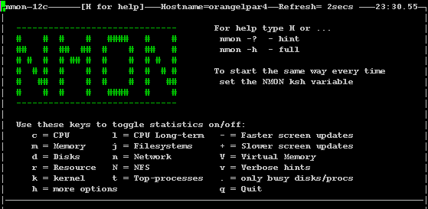
This is the Help section
- If you hit "h" you get this Help section with loads of hints. Hit "h" again to remove the Help
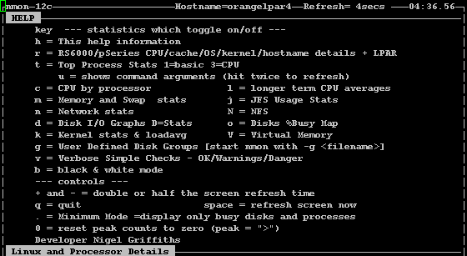
Resources section
- Hit "r" for Resources to find out what nmon can discover about your processors and Linux OS version and other features
- This is a bit of a weak area in Linux and vendors do this differently or not at all.
- In this case we have SUSE SLES 10.2 running on four 4.2 GHz POWER6 CPUs
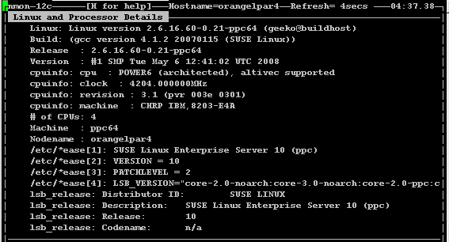
POWER LPAR details
- This is Linux on Power running in a Logical Partition (LPAR) for this platform only we have LPAR details (hit "p")
- We can see the LPAR is only consuming 0.004 of a single Power 6 Processor as it is just idling.
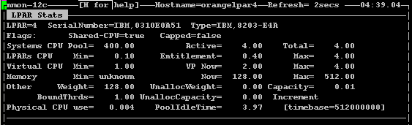
CPU Stats - Utilisation
- Hit "c" for the CPU stats.
- Here we see the four CPUs
- I ran a load generator (nstress) to get the graphs active
- "U" is user time, "s" is System time and "W" id waiting for Disk I/O time.
- Obviously blank is used for idle time.
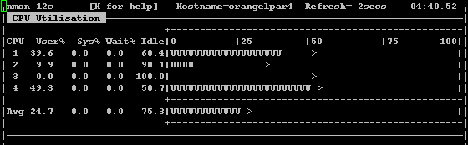
CPU Stats - again
- This time the machine is busier
- Note the ">" marks are the peak CPU usage - if you hit "0" (zero) these are reset to the far left.
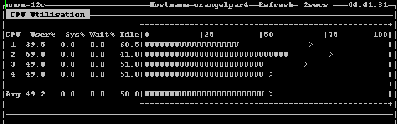
CPU Long Term Graph
- Hit "l" (lowercase L) to see these. "l" for long term
- On peaky workloads like a web server you can drive yourself mad watching the above graph fluctuate up and down and guessing an average
- This graph lets you see the last 70 snapshots and moves to the right. Once full it will wrap around.
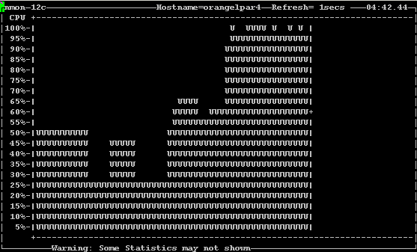
CPU Long Term Graph - again
- Note the top left now says 4 seconds - I slowed down the update and so snapshot rate of nmon to show a longer period of time.
- Faster and Slower screen Updates - this works regardless of the stats you are watching:
  - Hit "-" to halve the time nmon pauses between updates of the screen i.e. if it is set to 2 seconds now you get updates once a second
  - Hit"+" to double the time nmon pauses between updates of the screen i.e. if it is set to 2 seconds now you get updates once in 4 seconds
  - You can't go below 1 second - nmon would take too much CPU time for that to make sense
  - Faster is good to watch for peaks
  - Slower is good to even out the peaks to see a stable average
- Also note the "+" on the moving vertical bar - this shows the average number for the graphed data.
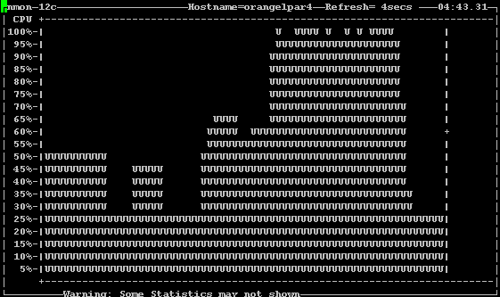
Memory Stats
- Hit "m" for memory details
- Note: this is a Power processor based system - there is no high memory as the Power processor has been 64 bit for a decade or more and these bizarre workaround to extend memory are not required.
- We can see 15 MB of free RAM out of 484MB
- And the paging space has not been used, yet!
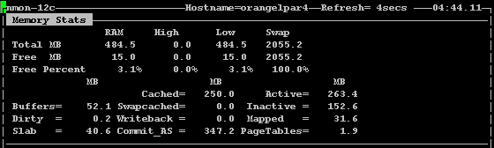
Disk Graphs
- Hit "d" for disk graphs
- Note: that only sda = the actual disk gives us statistics and not the disk partitions sda1, sda2, etc.
- This is, of course, a very small machine with just the one disk.
- If we had lots more disk we may not be able to see them all.
- Try making the font smaller and/or the window larger to show more lines
- If you hit "." (dot) then only the busy disks are shown - this works on Top Processes too.
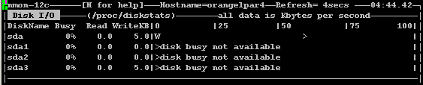
Disk Graphs - with workload
- Here we see the disk is 23% busy and writing 19 MB/s
- The graph shows "W" for Writing and "R" for Reading I/O
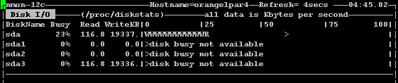
Disk Stats
- Hit "D" for the Disks but this time the Numbers in more Detail.
- We can see the numbers of transfers and block sizes etc.
- Also we see the peak values - these can be reset to zero by hitting "0" (zero)
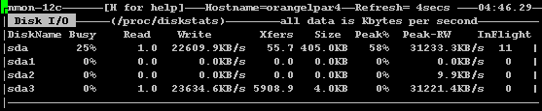
File Systems
- Hit "j" for Journalling file systems - OK "f" would make more sense but that was used for something else in the past!
- Here we see the root filesystem is 61% full
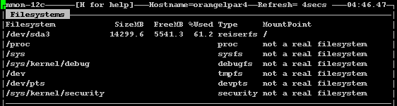
Network Stats
- Hit "n"
- All pretty obvious (I hope)
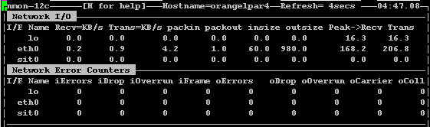
Network Stats - without error numbers
- If you wait a few seconds and there are no errors the lower panel is switched off.
- It will reappear is network error happen.
- On some machines with a dozen networks this saves a lot of screen space
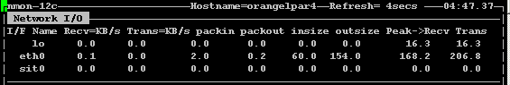
Network File System (NFS)
- Hit "N"
- OK this machine was not mounted or mounting NFS so the numbers are all zero.
- Boring but I hope you get the idea.
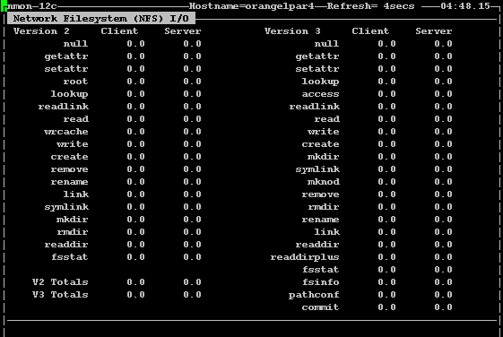
Kernel Stats
- Hit "k"
- Linux does not have so may of these but we have the important once like Run Queue, Forks, Load average are not that useful as nmon already collects the detailed CPU stats and we have Uptime here too.
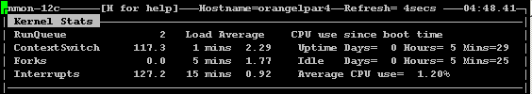
Disk Rain Diagram
- Hit "o" (lowercase Oh!)
- With just one disk this looks stupid (see the single "_" but imagine you had 640.
- The panel would have 10 lines and one character per disk
- As each disk gets busier more pixels are added to its character.
- This gives you a quick idea of how busy your disks are, as a whole.
- You also see unused disks or ranges of disks that are particularly busy.
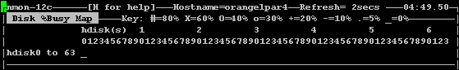
Top Process Stats
- Hit "t" to see the processes
- Default mode is 3 and this arranges them in CPU use order.
- You can see the big hitters are processes called "yes" and "ncpu" from the nstress tools
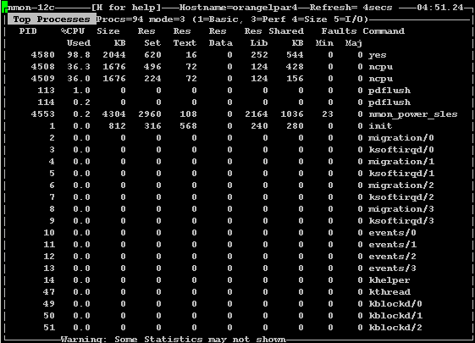
Top Processes in mode 1 = more details
- Have the top Processes on screen (Hit "t") then hit "1" for mode 1
- There are different stats shown including status, nice and priority
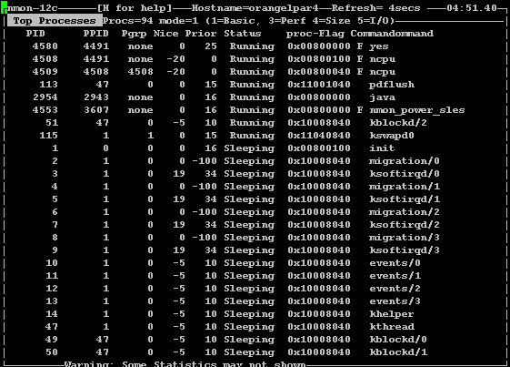
Top Processes in mode 4 = size order
- Have the top Processes on screen (Hit "t") then hit "4" for mode 4
- Here the processes are in memory size order
- You can see the largest process in 504 MB and called "java" - no surprise there then!
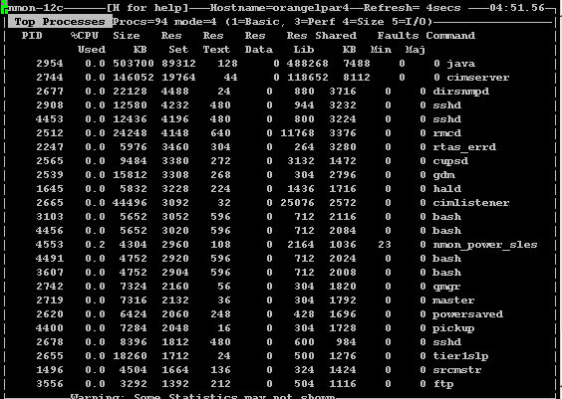

Sample Graphs from the nmon Analyser
CPU with Disk I/O to show the relationship between them
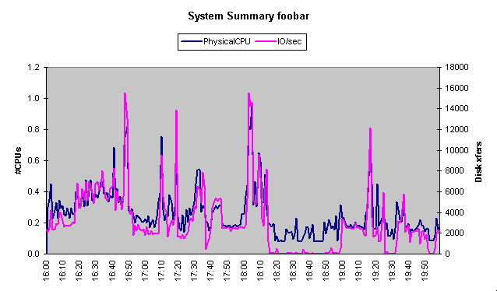
Individual CPU use on this 6 CPU Logical partition
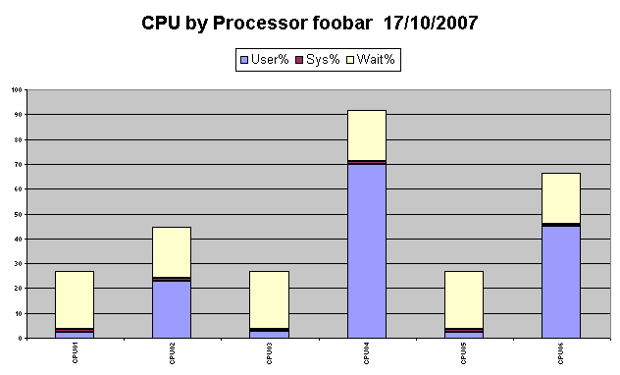
CPU compared with Shared CPU Entitlement (Power Systems only)
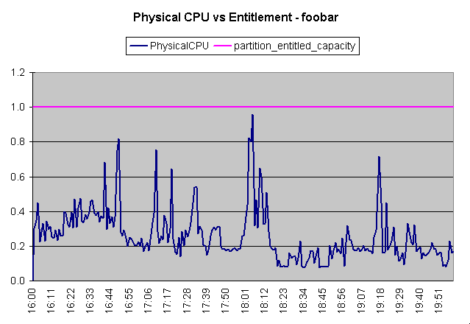
Disk read and Write with IO/second
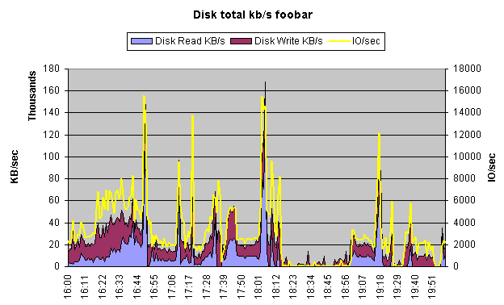
Hot Disks in order with Average, Weighted Average (average when in use) and Peak values
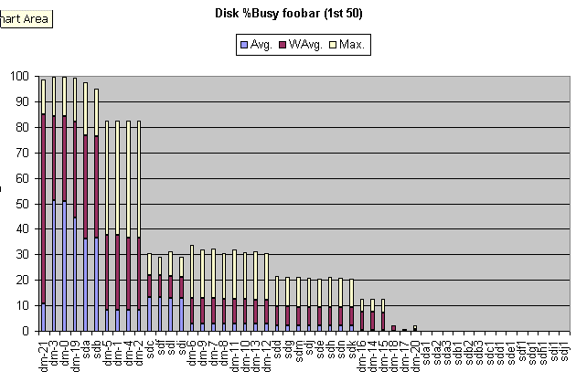
Free Memory
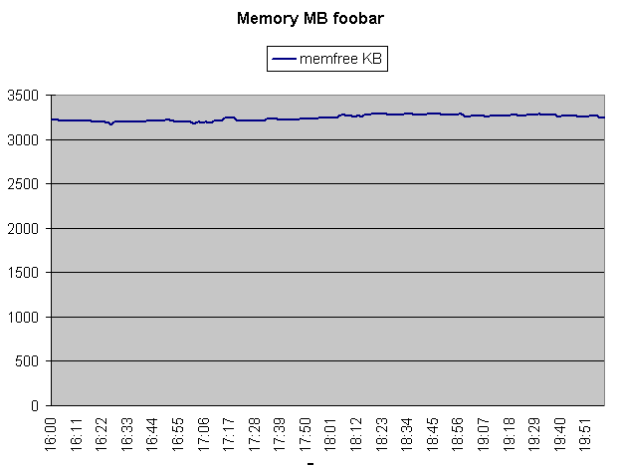
Network Read (top) and Write (bottom) - Iceberg view
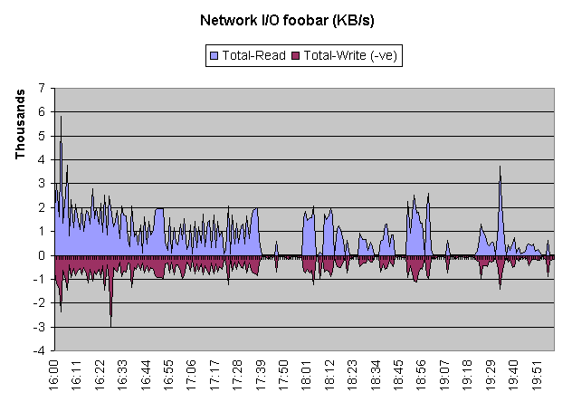
Top Processes - in this case DB2
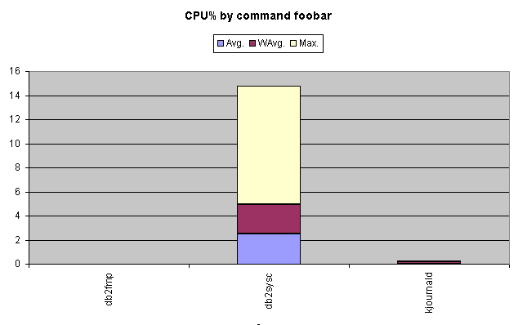
Run Queue
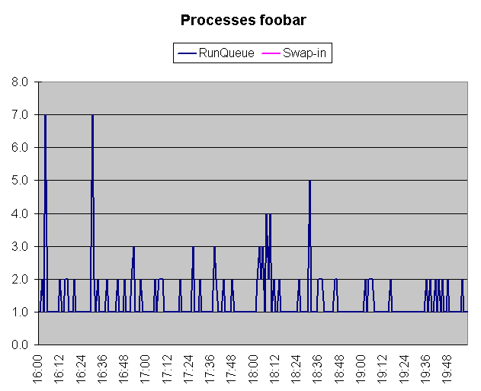
Process switches - kernel switching to a new process
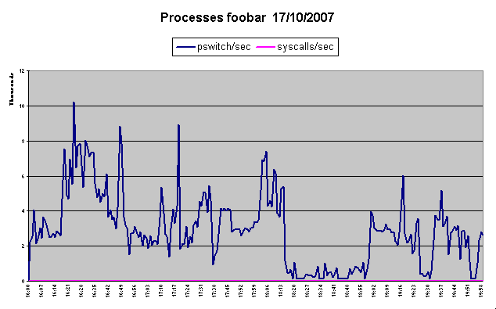
CPU Utilisation
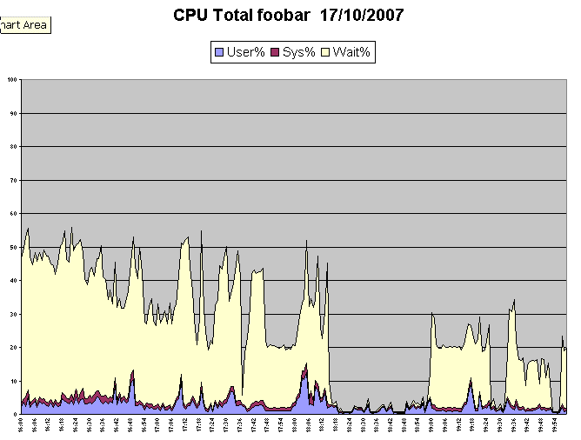
Pivot table covering Top Processes over time
